Instruction how to send Rubles from **Rosselhoz Bank** to NIIB

*Through mobile application of* **Rosselhoz Bank**

1. You need to download the application **Rosselhoz Bank** in Google Play or App Store.

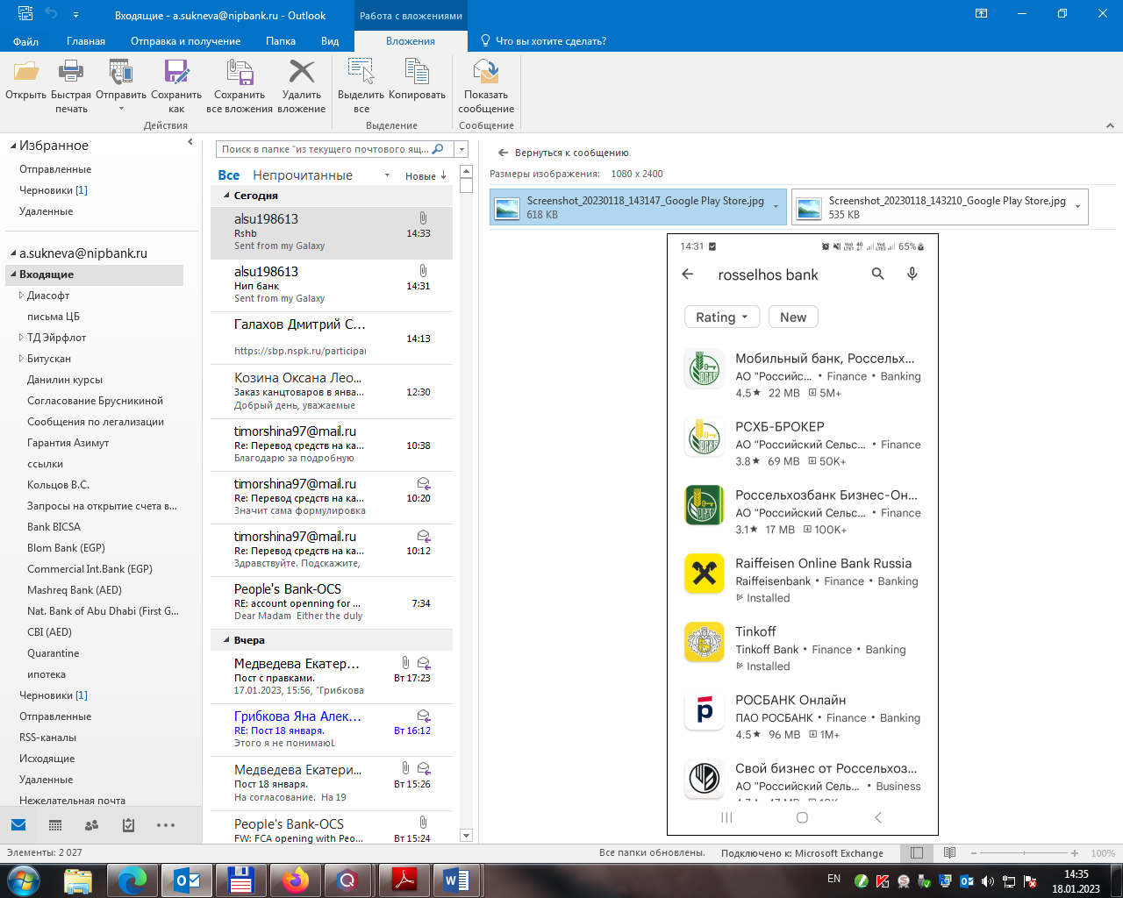

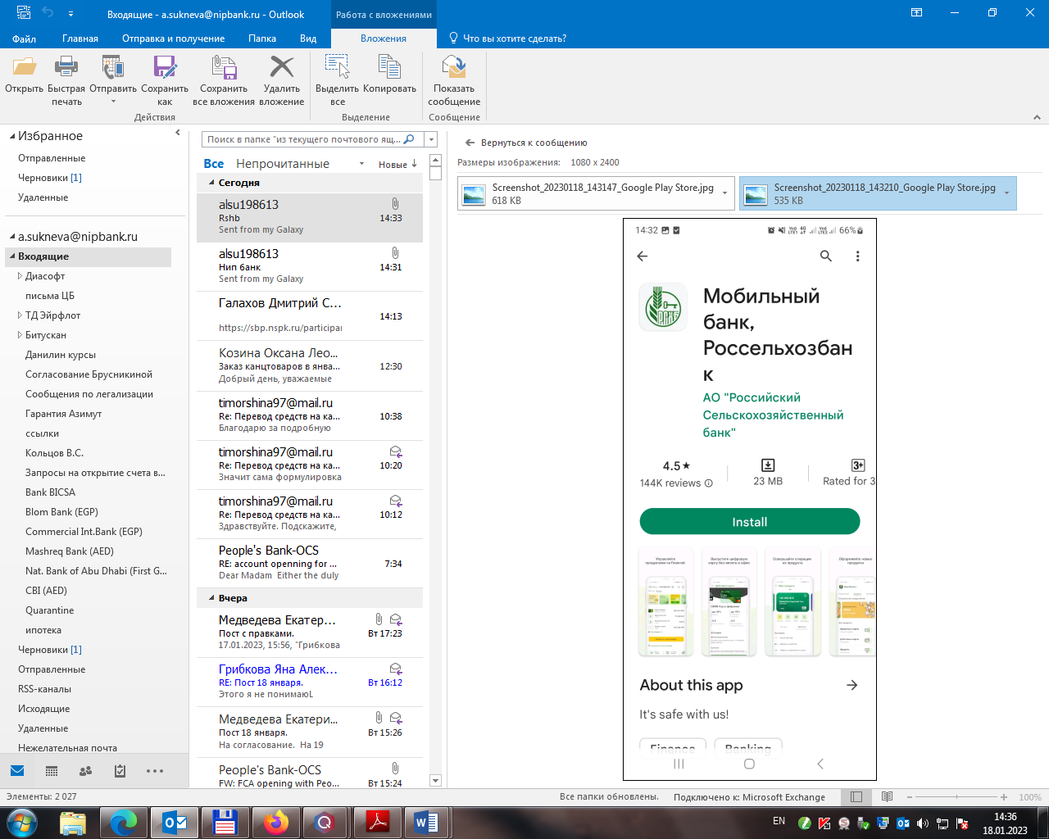

1. Log in to Rosselhozbank application by your pin, password or finger print.

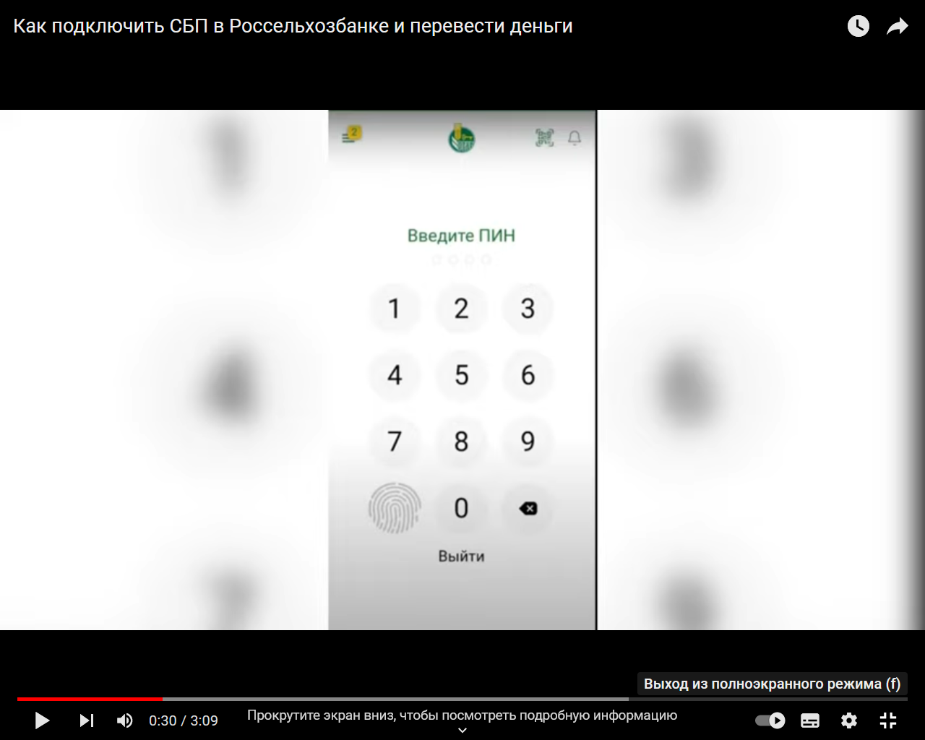

1. **To transfer the funds to another bank by phone number via FPS:**

* Open the main page of the mobile application. At the very bottom, choose a payment section («Платежи»).

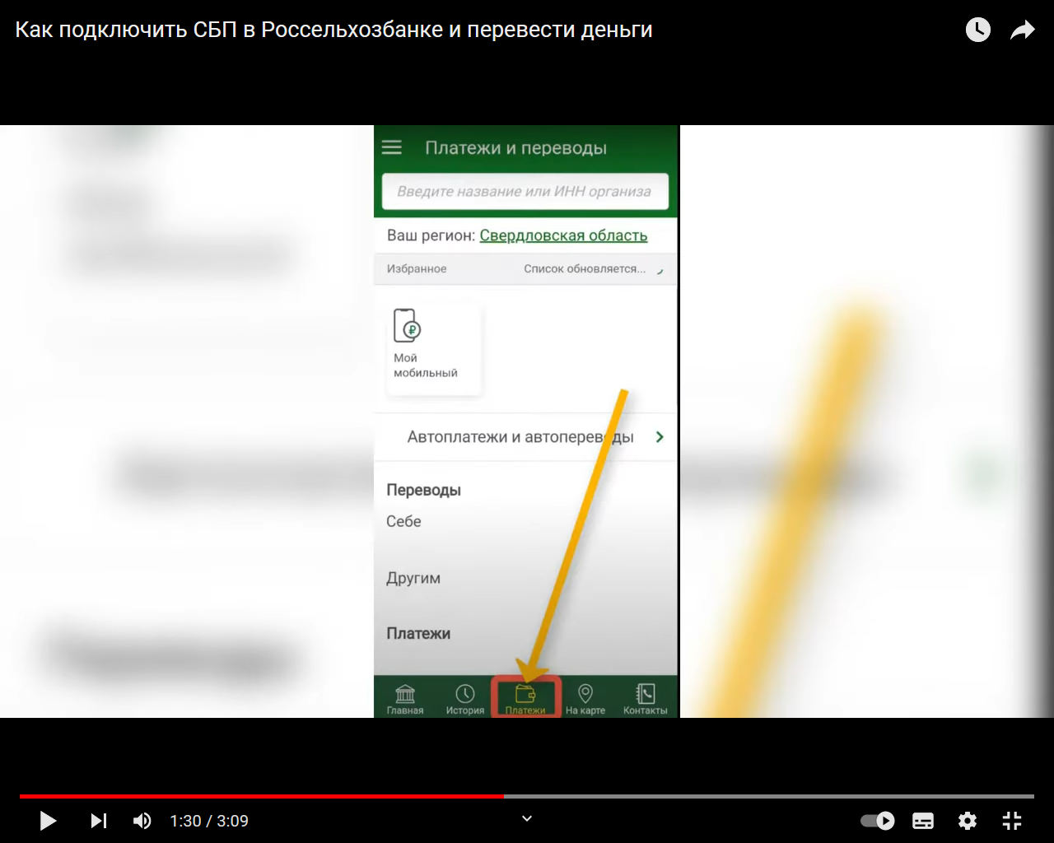

* Among the options for sending, choose “By phone to another bank via FPS” («По телефону в другой банк через СБП»).

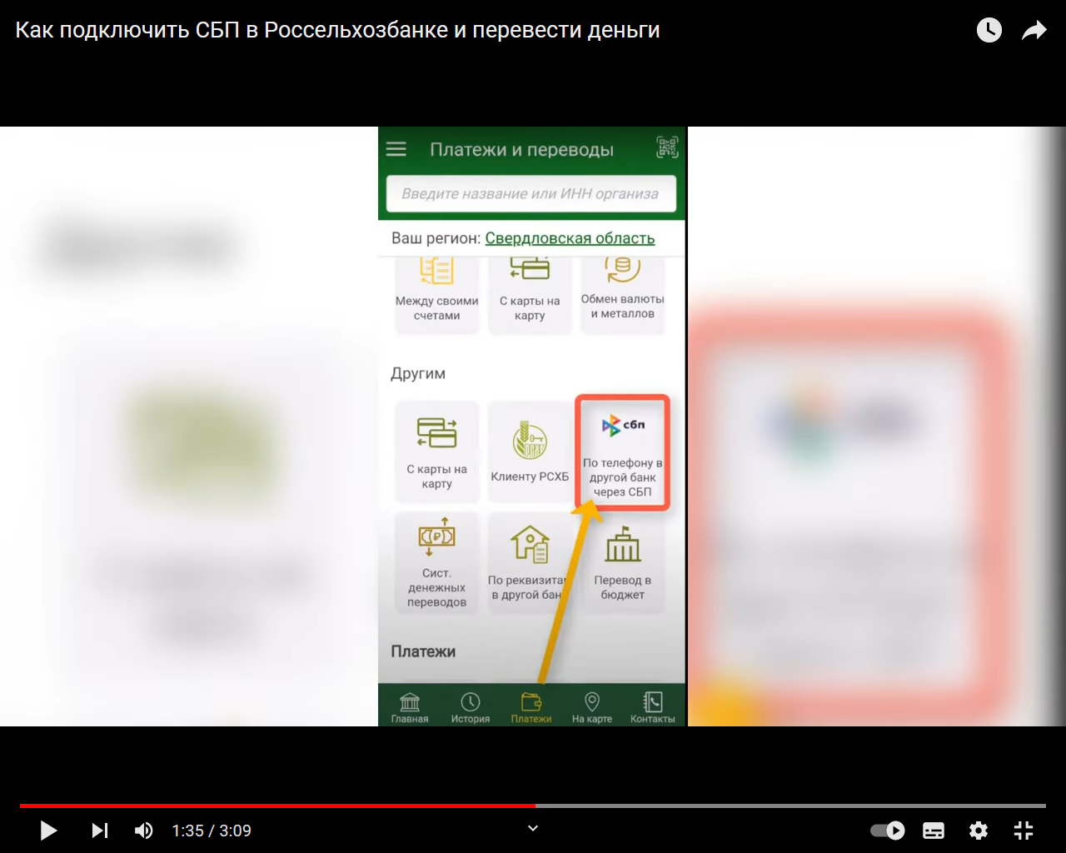

* A form will open to fill in, in which you first need to specify the recipient's phone number (the number you provided for NIIB with country code +7).

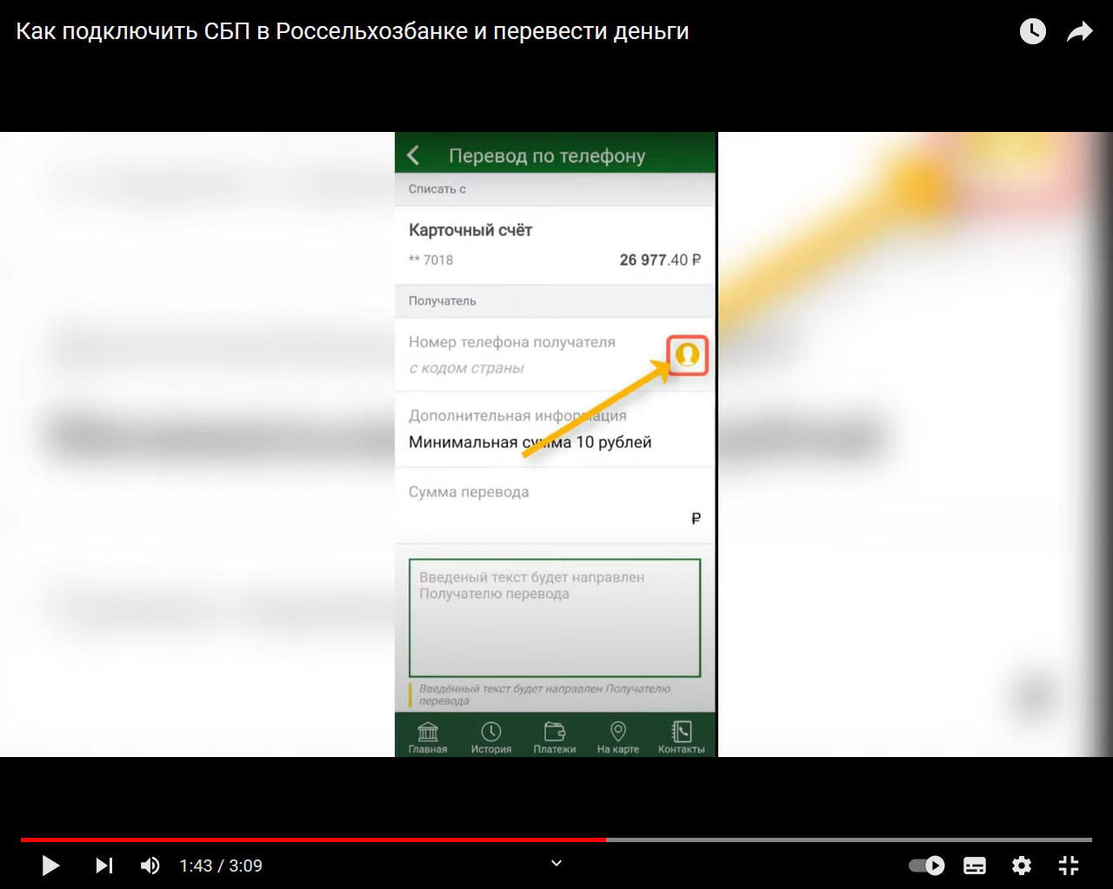

* Next, the sender selects the bank where to send funds, for example Natsinvestprombank (you need to type it in Russian – Нацинвестпромбанк).

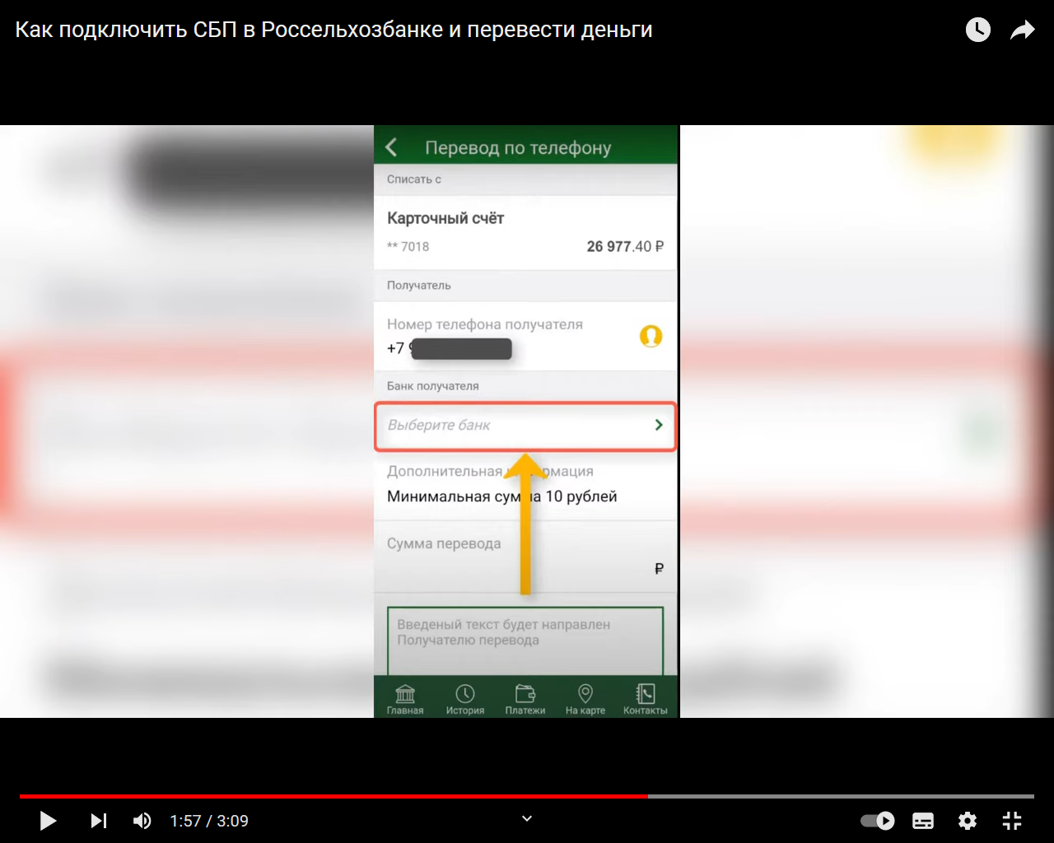

* Next, specifies the amount («Сумма перевода»). If necessary, you can fill in the message field to the recipient.

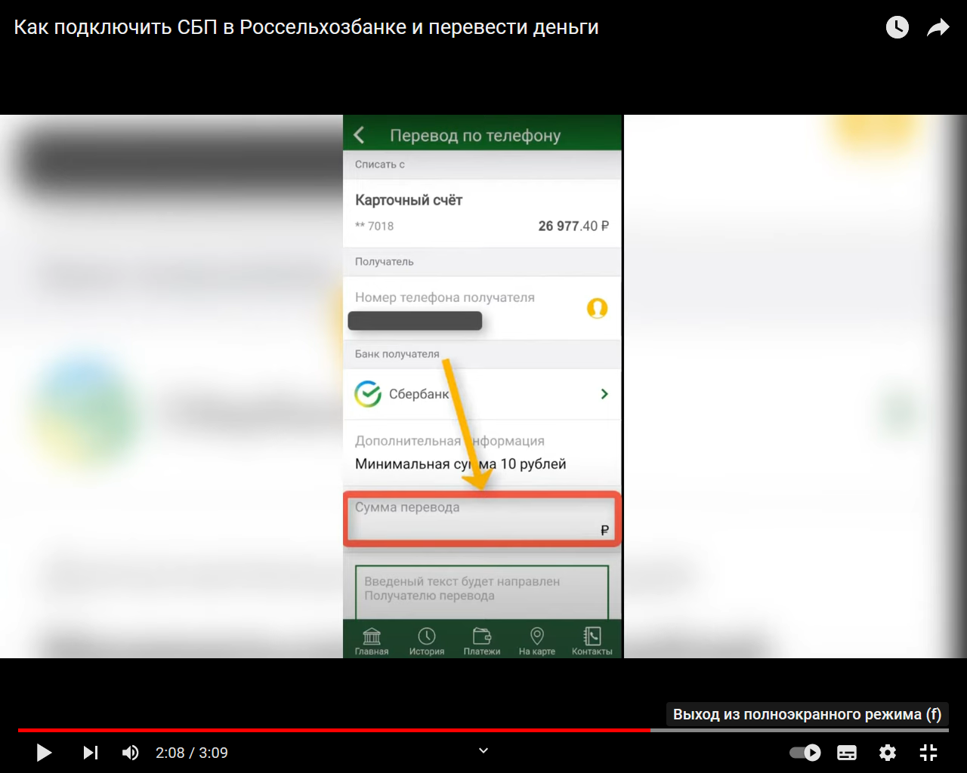

* After entering all the information, check the correctness of the entered data and click the Continue button («Продолжить»).

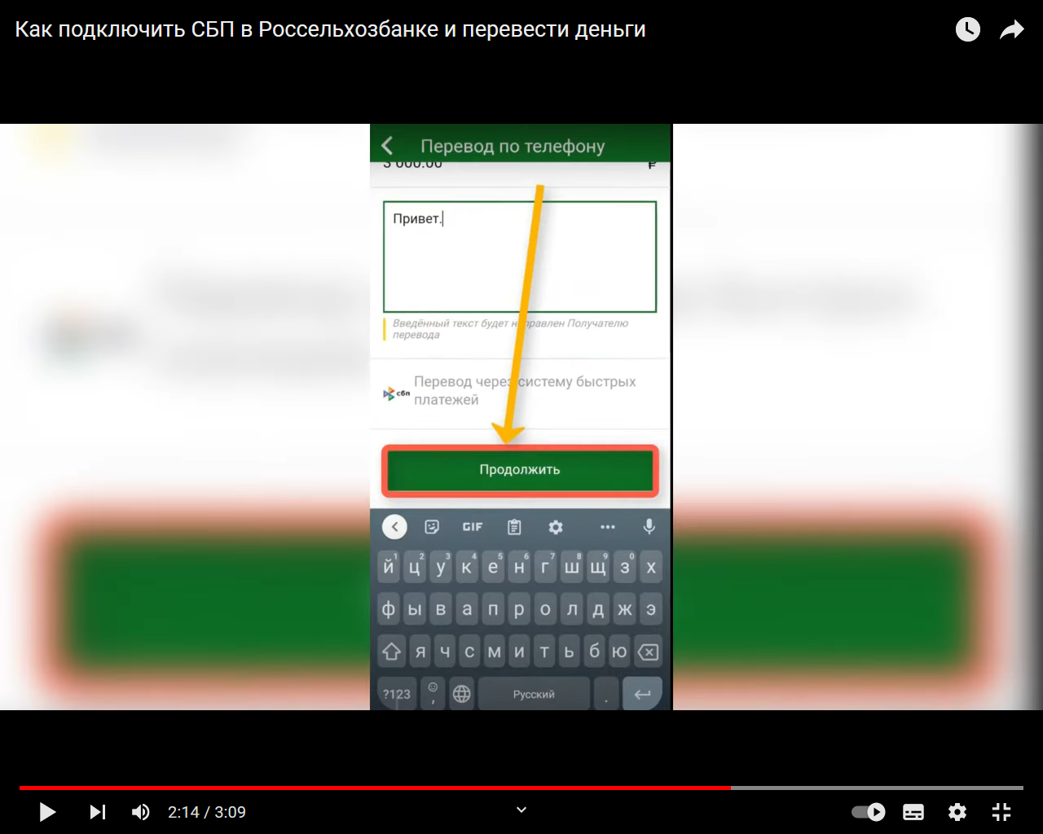

* Confirm the action by fingerprint or a one-time password.

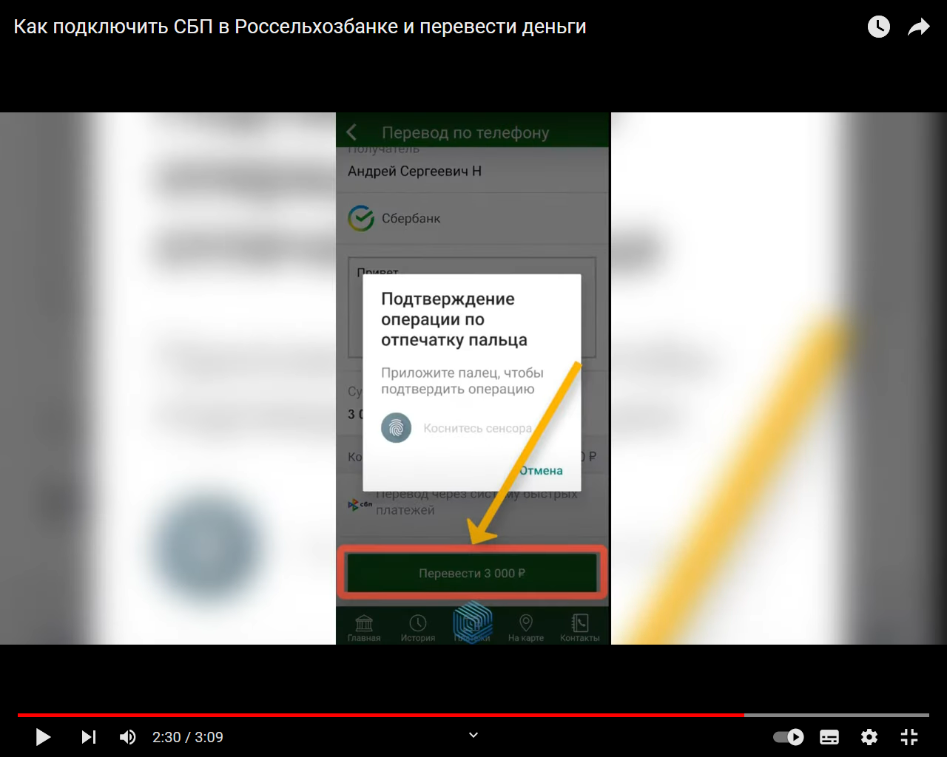

The payment is done.

